1. What is an operating system?
Operating System is the first software you see when you turn on the system and it is the last software you see when you turn off the system. Operating System is a program that gets loaded at the time of boot up and it is responsible for running other application programs. Operating system can be considered as a resource manager and it provides the base on which other programs can be written.
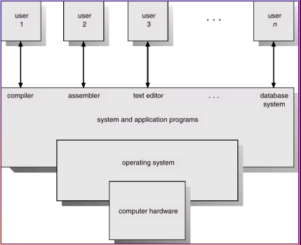

In other words, Operating System is a program that controls the execution of application programs and acts as an interface between applications and hardware.
Operating system interface
Hardware interface
User programs
Operating system
Hardware

2. Why do you need an operating system?
A modern computer consists of one or more processors, main memory, hard disks and a set of input output devices. Altogether a computer system is very complex. Without an operating system the application programmer has to be concerned about the working of the device drivers and also about the optimal utilization of the resources that seems to be very difficult. The solution was to put a layer of software above the bare hardware. This layer of software called the operating system shields the programmers from the complexity of the hardware.

3. Operating System objectives and functions
Operating Systems are primarily resource managers; the main resources they manage are computer hardware in the form of processors, storage, input/output devices, communication devices and data. Its objectives are
(i) Convenience: An Operating System makes the computer more convenient to use.
(ii) Efficiency: An Operating System allows computer system resources to be used in an efficient manner.
(iii) Ability to evolve: An Operating System should be constructed in such a way as to permit effective development, testing, and introduction of new system functions without interfering with service.
The main functions of operating system are:
(i) Operating System as a user/Computer interface - The Operating System masks the details of the hardware from the programmer and provides the programmer with a convenient interface for using the system. It acts as mediator, making it easier for the programmer and for application programs to access and use the Operating System facilities and services. The Operating System provides the following services:
1. Program development – The Operating System provides a variety of facilities and services such as editors and debuggers, to assist the programmer in creating programs.
2. Program execution – A number of tasks need to be performed to execute a program. Instructions and data must be loaded into main memory, I/O devices and files must be initialized and other resources must be prepared. The Operating System handles all these tasks for the user.
- 3. I/O Management – Each I/O device requires its own particular set of instructions, or control signals, for operation. All these are managed by Operating System.

- 4. File system manipulation - Programs need to read and write files and directories, create and delete them, search them, list file information, and set permission.
- 5. System Access - Operating System controls access to system as a whole and to specific resources. The access function also provides the protection to data and resources and resolves conflicts during contention of resources.
- 6. Error detection and recovery - Operating System needs to be constantly aware of Operating System errors. The errors can be of
(1) Internal and external hardware errors
    - memory error
    - device failure
- software errors
    - arithmetic overflow
    - access forbidden memory locations
- For each type of error, Operating System should take the appropriate action to ensure correct and consistent computing. Debugging facilities can greatly enhance the user’s and programmer’s abilities to efficiently use the system.
- 7. Accounting – A good Operating System collects usage statistics for various resources and monitors performance parameters such as response time.

(ii) Operating System as resource manager - Operating System manages all the resources of the computer system. Many hardware and software resources are needed to solve a problem. These include CPU time, memory space, file storage, I/O devices and so on. The operating system as a manager of these resources, allocates resources to programs of users as required by the tasks. Since there is always a possibility of conflicts for resources because of more than one user requesting for resources, the operating system resolves the conflicts for efficient operation of the computer system. Operating System ensures optimum utilization of the system resources. Thus operating system is a resource allocator. The operating system as a control program controls the execution of user programs to avoid errors and improve use of the computer system.
A computer system has been developed to execute user programs there by making work easier for the user. But the bare hardware alone is not easy to use. Hence application programs are developed. These require certain common operations such as I/O device handling. The common functions of controlling and allocating resources are present in one piece of software – the operating system.

3. Ease of evolution of an Operating System
Operating System will evolve over time for a number of reasons:
1. Hardware upgrades and new type of hardware. For e.g. early UNIX systems did not support paging.
2. New services – In response to user demand or in response to the needs of system managers, the operating system will expand to offer new services.
3. Fixes – When faults are detected fixes need to be made.

The evolution of Operating System

The first and second generation – The 1940’s and the 1950’s
The computer in the 1940’s didn’t have an operating system. Programs were entered into the computer one bit at a time on a row of mechanical switches. The machine consisted of display lights, toggle switches, some input device like a card reader and a printer. Eventually machine languages were introduced.
The evolution of Operating System over the years is as follows
- Serial processing - Here the programmer interacted directly with the hardware and there was no Operating System. Machines run from a console with display lights and toggle switches, input device, and printer. Programs were in machine language and loaded via input devices. Error condition was indicated by lights. For the correct program, the output appeared on the printer. The main problems are
(a) Scheduling – A sign up sheet was used to reserve computer time. A user could sign up for a block of time. Sometimes this may result in wasted computer idle time if the user finishes his job before time. Otherwise the user may not finish his work in the allotted time and will have to reserve some other slot to complete his job.
(b) Setup time - A single job involves loading the compiler and the high level language program (source program) into memory, saving the compiled program (object program), and then loading and linking the object program and the common functions. It includes mounting the tapes and disk packs, placing the appropriate forms in the printer, punching in the time cards etc. When the job is completed, the tapes and disk packs were removed, time cards were “punched out” etc. Thus considerable amount of time was wasted for setting up the job.
2. Simple Batch System - Since the machines were expensive users began to think of maximizing machine utilization. They realized that if the job-to-job transition is automated they could cut down the time wasted between the jobs. The first operating system was designed for this purpose by the General Motors Research Laboratories for their IBM 701 mainframe beginning in early 1956.

The simple batch-processing scheme used software called monitor. The user did not have any direct interaction with the computer system. Instead the users submitted their jobs either on cards or tapes to a computer operator. A job consists of the program, data and control information (control cards). The operator batched the jobs and placed the entire batch on an input device. Each program when it completes processing will branch back to the monitor and the monitor will automatically begin loading the next program. It is the monitor that controls the sequence of events. So much of the monitor should always be in the memory and should be available for execution. That part of the monitor, which resides in the memory is called Resident Monitor.
Job control language (JCL) - It is a special type of programming language used to provide instructions to the monitor. These job control instructions set up the job by telling the computer whether the cards following it contain data or programs, what programming language is used, the approximate execution time, etc. When the current job terminated, the job stream reader automatically reads in the control language statements for the next job. The format of a job looks like this:
$JOB
$FTN
.
.
$LOAD
$RUN
.
.
$END
Hardware Features
1. Memory protection – While the user program is executing, it must not alter the memory area containing the monitor.
2. Timer – A timer is used to prevent a single job from monopolizing the system.
3. Privileged instructions - Certain instructions are designated as privileged and can be executed only by the monitor.
4. Interrupts – This feature gives the Operating System more flexibility in relinquishing control to and regaining control from user programs.

Drawbacks
In the batch Operating System the user didn’t have any interaction with the system while the job is executing. The user submits his job and obtains the output at some later time. This might take minutes, hours or even days. The output consisted of the result of the program and the final memory and register contents for debugging. The turnaround time was very high.

- The third generation – The 1960’s - Multiprogrammed Batch Systems
If more than one job could be held in the memory, when one job waits for I/O, the processor can switch to some other job that is not waiting for I/O. This concept which the modern Operating System follows is called multiprogramming or multitasking. In uniprogramming, processor must wait for I/O instruction to complete before proceeding.

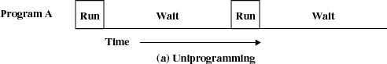

But in multiprogramming, when one job needs to wait for I/O, the processor can switch to the other job.

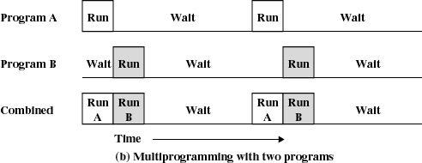

Yet another major feature in this Operating System was the technique called spooling (simultaneous peripheral operations on line). In spooling, a high-speed device like a disk is used in between a running program and a low-speed device involved with the input/output. Instead of writing directly to a printer outputs are written to the disk. Programs can run to completion faster, and other programs can be initiated sooner when the printer becomes available, the outputs may be printed.
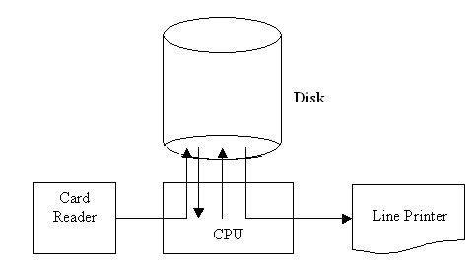

4. Time Sharing Systems
Timesharing (multitasking) is logical extension in which CPU switches jobs so frequently that users can interact with each job while it is running, creating interactive computing. Its main features are
  - Response time should be < 1 second
  - Each user has at least one program executing in memory [process
  - If several jobs ready to run at the same time [ CPU scheduling
  - If processes don’t fit in memory, swapping moves them in and out to run
  - Virtual memory allows execution of processes not completely in memory
In these systems multiprogramming is used to handle multiple interactive jobs. Here the processors time is shared among multiple users. Multiple users simultaneously access the system through different terminals. The difference of time sharing system from a multiprogrammed system is that in multiprogramming, the computer works on one program until it reaches a logical stopping point, such as an input/output event, while for timesharing system, every job is allocated a specific small time period after which the system switches to the next job.
The problems here are
- Since multiple jobs reside in memory at a time they must be protected from interfering with each other.
- The file system must be protected so that only authorized users will access a particular file.
- The contention of resources such as printers and storage devices must be handled.

5. Multiprocessor Systems (Parallel systems or Tightly coupled systems) - These systems have more than one processor sharing the other resources such as computer bus, clock, memory and peripheral devices.
Advantages of multiprocessor systems are
- Increased throughput – Throughput is the amount of work done in unit time. By increasing the number of processors more work can be done than with a single processor.
- Economy of sale – Multiprocessor systems save more money than multiple single processor systems because the processors in the multiprocessor systems share the system resources.
- Increased reliability – The failure of one processor will not halt the system if the work id distributed properly among several processors.
Multiprocessing can be symmetric multiprocessing or asymmetric multiprocessing.
Symmetric multiprocessing – each processor runs an identical copy of the Operating System and these copies communicate with one another as needed.
Asymmetric Multiprocessing – one of the processor is assigned as the master. The master schedules and allocates work to the slave processors.

6. Distributed Systems - In distributed processors the computation is distributed among multiple processors. But to its users it appears as a uniprocessor system. Users need not bother about where their files are located or where their programs are run. The processors do not share memory, peripheral devices or a clock. Each processor has its own local memory and clock. The processors communicate with one another through various communications lines, such as high-speed buses or telephone lines. Distributed systems requires a networking interface either a LAN or WAN. The systems can be either peer to peer or client server model.
Client Server Systems
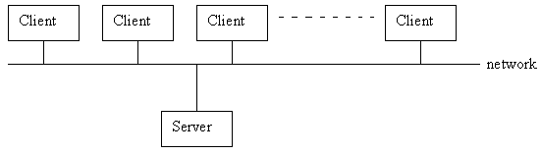
Terminals connected to centralized systems are supplanted by small PCs. Centralized systems ct as server to satisfy requested generated by clients.

There are 2 types of server systems.
(i) Compute-server that provides an interface to client to request services (i.e. database)
(ii) File-server that provides interface for clients to store and retrieve files
Peer-to-peer Systems
The systems connected to the web can be considered as peer-to-peer systems. These systems do not share memory or clock. These systems are also called loosely coupled systems.

7. Clustered Systems - Like multiprocessor systems clustered machine gather multiple CPUs to perform computation. The difference is that it is composed of two or more individual systems coupled together. They share storage and is linked by LAN. There are two types of clustering, asymmetric clustering and symmetric clustering.
Asymmetric clustering – One machine is in hot standby mode and other machine runs the applications. The hot standby machine just monitors the active server. If the active server fails the hot standby machine becomes the active server.
Symmetric clustering – two or more machines runs applications and at the same time they monitors each other.

8. Real-Time Systems - A real time system has well defined fixed time constraints. Processing should be done within the defined constraints. Real time Operating Systems are used as a control device in a dedicated application such as controlling scientific experiments, medical imaging systems, industrial control systems, and some display systems. Real-Time systems are classified as hard or soft real-time.

Hard real-time
- Guarantees critical task completion on time.
- Secondary storage limited or absent, data stored in short term memory, or read-only memory (ROM)
- Conflicts with time-sharing systems, not supported by general-purpose Operating Systems.
- Advanced Operating System features are absent (e.g. virtual memory is absent).

Soft real-time
- Less restrictive.
- A critical real time task gets priority over other tasks and it retains its priority until it completes.
- Limited utility in industrial control of robotics

Useful in applications (multimedia, virtual reality, under sea explorations etc.) requiring advanced operating-system features.

9. Handheld Systems
These systems include personal digital assistants (PDAs), palm pilots and cellular telephones with connectivity to a network such as internet.
Limitations of handheld systems are
- Small amount of memory
- Include slow processors – increasing the speed will need more power that will require larger batteries that should be replaced frequently.
- Small display screens

Microkernel architecture - It assigns only a few essential functions to the kernel, including address spaces, IPC, and basic scheduling. Other services are provided by processes that run in user mode. Other features are
- client-server model, IPC between clients and servers
- the micro-kernel provides protected communication
- Operating System functions implemented as user-level servers
- flexible but efficiency is the problem
- easy to extend for distributed systems

Important OS Concepts
Process - A process can be defines as a program in execution.
- An instance of a program running on a computer.
- The entity that can be assigned to and executed on a processor.
- A unit of activity characterized by a single sequential thread of execution, a current state, and an associated set of system resources.
A process is composed of 3 components: (1) An executable program (2) the associated data needed by the program (3) the execution context of the program. Operating System manages the processes and it performs the following activities: Creates and deletes user and system processes, Suspends and resumes processes, Provides mechanisms for process synchronization, Provides mechanisms for process communication, Provides mechanisms for deadlock handling.

Files
OS acts as a virtual machine. OS hides the peculiarities of the I/O devices and provides the user with an abstract model of device independent files. File is a collection of related information. To group the files together OS supports the concept of directories. A file is specified by its pathname. Pathname can be absolute or relative. Absolute pathname specifies the path of the file starting with the root directory whereas relative pathname starts with the current working directory. OS protects the file from unauthorized access. Files are protected by a 9 bit binary protection code (three 3 bit fields). The first 3 bits specifies the owner, second 3 bits specifies the other members of the group and the third 3 bits specifies the universe. Out of the three bits in a group the first bit is for read access, second bit for write access and the third bit for execute access.
The code looks like rwx r _ x _ _ x
A file descriptor or handle is associated for each file that is opened for I/O. The file descriptor is a small integer used to identify a file. The kernel assigns file descriptors when system calls like open, create, dup etc. are successful. In UNIX file descriptor 0, 1 and 2 are for standard input, standard output and standard error.
Pipes
Pipes are pseudo file. They are used to connect two processes.

When process A needs to send data to process B, it writes in the pipe as though it is an output file and B reads from the file as it is an input file. Operating Systems like UNIX, LINUX and MS-DOS supports pipes.
System Calls
The OS contains a set of routines for performing low level operations. The user programs requests services of the OS by making system calls. A system call is an interface between a process and the OS. A user program cannot directly make a system call. Corresponding to each system call there is a library routine that the user programs can call. E.g. open, create, close, read, write, lseek, fork, exec
The Shell
The shell is the primary interface between the user and the operating system. When you log in your photon lab, a shell starts up. It starts up by typing a prompt. This is to inform the user that it is ready to accept a command. Now when you type in vi in the command prompt, it opens up the vi editor.

Kernel
The kernel is the central module of an operating system. It is the part of the operating system that loads first, and it remains in main memory. Because it stays in memory, it is important for the kernel to be as small as possible while still providing all the essential services required by other parts of the operating system and applications. Typically, the kernel is responsible for memory management, process and task management, and disk management.
Memory management - The Operating System has 5 storage management responsibilities
- Process isolation: Operating System must prevent independent processes from interfering with the data and memory of each other.
- Automatic allocation and Management: Programs should be dynamically allocated
- Support for modular programming
- Protection and access control
- Long term storage
File management - It Implements long-term storage. In connection with file management the Operating System is responsible for the following activities
- Creating and deleting files
- Creating and deleting directories
- Supporting primitives for manipulating files and directories
- Mapping files into secondary storage
- Backing up files on storage media
Information protection and security - Here OS is dealing with
(i) Access control - To regulate user access to the system.
(ii) Information flow control - To regulate flow of data within the system and its delivery to users.
(iii) Certification - To prove that access and flow control perform according to specifications.
Scheduling and resource management - Resource allocation and scheduling policy must consider the following 3 factors:
(i) Fairness - To give equal and fair access to all processes
(ii) Differential responsiveness - To discriminate between different classes of jobs/users
(iii)Efficiency - To maximize throughput, minimize response time, and accommodate as many uses as possible.

System structure (O.S. Hierarchy) - We can view the system as a series of levels. Each level performs a related subset of functions. Each level relies on the next lower level to perform more primitive
functions. This decomposes a problem into a number of more manageable sub problems. The hierarchy can be defined as follows:
Level | Name | Objects | Example Operations
13 | Shell | User programming environment | Statements in shell language
12 | User processes | User processes | Quit, kill, suspend, resume
11 | Directories | Directories | Create, destroy, attach, detach, search, list
10 | Devices | External devices, such as printers, displays and keyboards | Create, destroy, open, close, read, write
9 | File System | Files | Create, destroy, open, close, read, write
8 | Communications | Pipes | Create, destroy, open, close, read, write
7 | Virtual Memory | Segments, pages | Read, write, fetch
6 | Local secondary store | Block of data, device channels | Read, write, allocate, free
5 | Primitive processes | Primitive process, semaphores, ready list | Suspend, resume, wait, signal
4 | Interrupts | Interrupt-handling programs | Invoke, mask, unmask, retry
3 | Procedures | Procedures, call stack, display | Mark stack, call, return
2 | Instruction set | Evaluation stack, micro-program interpreter, scalar and array data | Load, store, add, subtract, branch
1 | Electronic circuits | Registers, gates, buses etc. | Clear, transfer, activate, complement
Windows 2000
- Windows 2000 is a single user multitasking operating system.
- Windows 2000 is highly modular – each system function is managed by just one component of the operating system. Any module can be upgraded or removed without affecting the rest of the system.
- In Windows 2000 many functions outside the microkernel runs in kernel mode.
- Windows 2000 can be run on a variety of platforms.

The architecture of windows 2000 is shown below.
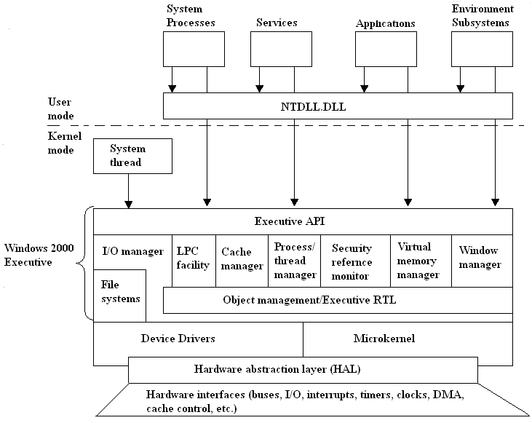
Architecture of Windows 2000

Hardware abstraction layer (HAL):
- HAL isolates the operating system from platform specific hardware differences. This is done by mapping between the generic hardware commands and those specific to certain platforms.
- It makes each machine’s hardware look the same to the kernel.
- It gives the support needed for symmetric multiprocessing.
Microkernel:
- Most used and most fundamental components of the operating system form the microkernel.
- Kernel constitutes thread scheduling, process switching, exception and interrupt handling and multiprocessor synchronization.
- Microkernel is the only part of operating system that is not preemptive or pageable.
Device Drivers:
- This includes file system and hardware device drivers.
- It translates I/O function calls into specific hardware device I/O requests.

Windows 2000 Executive:
The windows 2000 executive includes modules for specific system functions. It also provides an API for user mode software. The executive consists of the following modules:
I/O manager:
- Provides a framework through which I/O devices are accessible to applications.
- Implements all the Windows 2000 I/O APIs.
- Enforces security and naming for devices and file systems.
Object manager:
- It is responsible for the creation and deletion of Windows 2000 executive objects and ADT used to represent processes, threads and synchronization objects.
- It enforces uniform rules for naming and setting the security of objects.
- It creates object handles (object handles consists of the access control information and a pointer to the object).
Local Procedure Call facility:
- It enforces a client server relationship between the applications and executive subsystems. (The services of executive subsystems include memory services, process creation services, processor scheduling services etc.)
Cache manager:
- It causes the recently accessed disk data to reside in main memory for quick access thus improves the performance of file based I/O.
Process/thread manager:
- It tracks the process and thread objects.
Security reference monitor:
- It enforces access validation and audit generation rules for files, processes, address spaces and I/O devices.
Virtual memory manager:
- It maps virtual addresses in the process’s address space to physical addresses in the memory.
Window manager:
- It creates the windows oriented screen interface. Manages the graphics devices.

User Processes:
Windows 2000 supports four types of user processes.
Special system support processes:
This includes services not provided as part of Windows 2000 operating system. Examples are logon process, session manager etc.
Server Processes:
This includes Windows 2000 services such as event logger.
Environment subsystems:
This system is responsible for exposing the Windows 2000 services to user applications. It includes DLLs that converts the user application calls to Windows 2000 calls.
User applications:
This includes the application programs.

UNIX
- Here the underlying hardware is surrounded by the operating system software.
- Operating system is often called kernel to emphasize its isolation from the user and applications.
- Operating system is equipped with a number of user services and interfaces that are considered part of the system.
- These can be grouped into shell, other interface s/w and the components of C compiler.

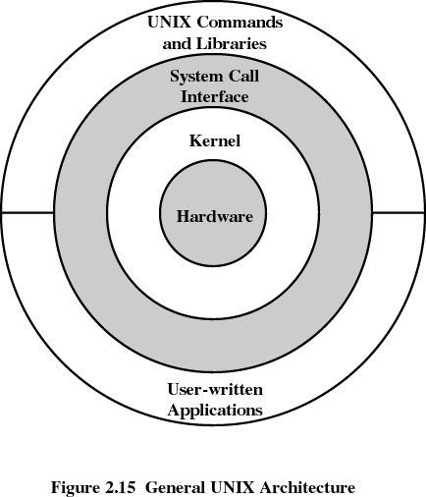

Shell
Shell is the interface between the user and the Operating System.
Three types of shells are available
- Bourne shell
Stephen Bourne of AT&T Bell laboratories wrote bourne shell. This is the most primitive and the standard shell used in UNIX Operating system.
- C shell
William Joy at the University of California at Berkeley wrote C shell. Many of its programming features resemble the syntax of C programming language, so the name C shell. Apart from Bourne shell it has got the following features,
History facility – user can call previously used commands and edit them for reuse.
Alias facility – user can give shorthand names for long command sequences.
- Korn shell
David Korn of AT&T Bell laboratories wrote Korn shell. It is the most popular shell. Its format and usage is same as that of Bourne shell but it has got the history and alias facilities.

Modern UNIX Systems
- System V Release 4 (SVR4)
- Solaris 2.x
- 4.4BSD
- Linux

Structure of Linux
Linux OS consists of three major components.
- Kernel
- Shell
- Utilities and application programs

The structure of Linux OS is shown in figure

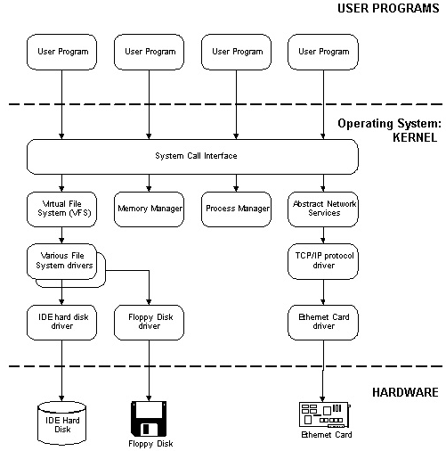

Kernel
- Linux kernel has a modular structure. It is built as a collection of source modules.
- Linux has a dynamic kernel – Kernel has the ability to load and unload modules according to requirements.
- Linux can run on a variety of platforms by loading the machine specific modules to support the new hardware.
Linux kernel consists of five components.
- Process Manager – handles process scheduling and accounting. Has the capability for multiprocessing and real-time process management.
- Memory Manager – It handles the virtual address space. Maps the virtual address to physical address. It also handles runtime memory allocation.
- Virtual File System – It is the layer that lies between the kernel and file system drivers.
- Network Interface – Enables communication.
- IPC Interface – Responsible for the interprocess communication.

Shell
Shell is the interface between the user and the operating system.
Three types of shells are available
- Bourne shell
Stephen Bourne of AT&T Bell laboratories wrote Bourne shell. This is the most primitive and the standard shell used in UNIX OS.
- C shell
William Joy at the University of California at Berkeley wrote C shell. Many of its programming features resemble the syntax of C programming language, so the name C shell. Apart from Bourne shell it has got the following features,
History facility – user can call previously used commands and edit them for reuse.
Alias facility – user can give shorthand names for long command sequences.
- Korn shell
David Korn of AT&T Bell laboratories wrote Korn shell. It is the most popular shell. Its format and usage is same as that of Bourne shell but it has got the history and alias facilities.

User
Linux is a multi user OS. The file of each user is secure from the other users. On Linux system each user has a unique identification with passwords to enhance security. Linux system supports two types of users.
- Ordinary users
After logging on to a system a user is taken directly to his home directory where his files and subdirectories are stored. An ordinary user can be a member of a group. Different types of privileges can be given to a user to access a file. For e.g., a file may be read and altered by the user who owns it, may only be read by other members of the same group and may not be accessed by other users.
- Super user
A super user is a privileged user who has full access to all the files in the system. The super user is normally known as root. He has the responsibility to administer and maintain the system.

